Lab 04

Flow Control Instructions

Lab Objectives
By the end of this lab, students will be able to:
- Understand how flow control instructions influence program execution.
- Use comparison and jump instructions for decision-making in assembly language.
- Implement conditional and unconditional branching.
- Relate assembly-level branching to high-level constructs (if-else, loops).
Introduction
Flow control instructions allow the program to change its normal sequential execution.
Instead of executing instructions one after another, the processor can jump, repeat, or branch depending on conditions. This is how if statements, loops, and switches in high-level languages are implemented at machine level.
The following instructions will be followed:
- JMP – Unconditional jump.
- CMP – Compare two operands and set flags.
- Conditional Jumps:
  - JE / JZ → Jump if equal / zero.
  - JNE / JNZ → Jump if not equal / not zero.
  - JG / JL / JGE / JLE → Jump if greater / less (signed).
  - JA / JB / JAE / JBE → Jump if above / below (unsigned).
- LOOP – Repeat a block until CX = 0.

Unconditional Jump: This program illustrates an unconditional jump. The JMP instruction transfers control to the label SKIP, causing the instruction in between to be bypassed. As a result, the value in AL remains 5.
MOV AL, 5
JMP SKIP
MOV AL, 9 ; this will be skipped
SKIP:
; AL = 5
Output
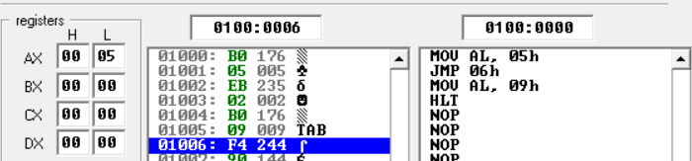
Another Example: Jump to desired instruction.
MOV AX, 5
JMP OTHER ; skip the unwanted instruction
MOV AX, 10 ; this line will never execute
OTHER:
ADD AX, 2 ; AX = 5 + 2 = 7
Output
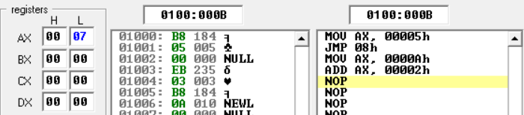
Block: In assembly, a block is simply a labeled section of code that groups related instructions.
Example
START: MOV AX, 5 ; Start block
ADD AX, 3
Practical Example
MOV AX, 5
START: ADD AX, 3 ; Start block
JMP START
Output
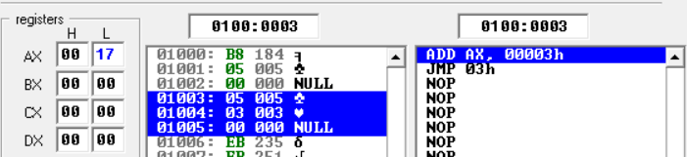
Loop: In x86 assembly, the CX register is commonly used as a loop counter. The LOOP instruction is specifically designed to work with CX: each time LOOP is executed, the processor automatically decrements CX by 1 and continues looping until CX becomes zero.
MOV CX, 5 ; set loop counter to 5
TOP:
; (your code here, e.g., increment a register)
LOOP TOP ; CX = CX - 1, repeat until CX = 0
Output
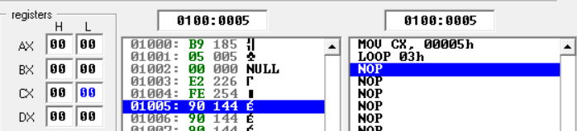
Practical Example:
MOV AX, 0 ; Initialize AX = 0
MOV CX, 5 ; Set loop counter = 5

START:
ADD AX, 1 ; Add 1 to AX
LOOP START ; Decrement CX, repeat until CX = 0
Explanation:
- AX starts at 0.
- CX is the counter (5 iterations).
- Each loop adds 1 to AX.
- After 5 repetitions, AX = 5 and CX = 0
- Program exits

CX and AX values at start.
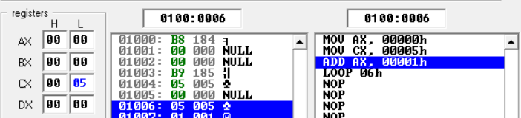
CX and AX values at end.
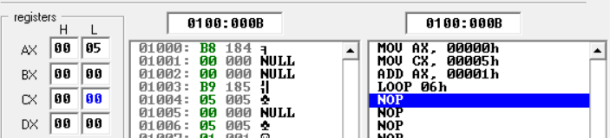
Difference between JMP and LOOP:
JMP → repeats forever (or until you add your own condition).
LOOP → repeats exactly CX times (automatic counter).

Class work: Repeat above example but using SUB operation (Initialize AX = 10).

Conditions in assembly: Conditions in assembly are decisions based on CPU flags (Zero, Sign, Carry, etc.) set by instructions like CMP or arithmetic operations. Conditional jumps (JE, JNE, JG, JL, etc.) test these flags to control program flow, enabling if, else, and loop structures.

Simple Example
MOV AX, 5 ; Store first number
MOV BX, 5 ; Store second number

CMP AX, BX ; Compare AX and BX
JE EQUAL ; Jump if AX == BX

MOV CX, 0 ; Runs only if AX != BX
JMP END

EQUAL:
MOV CX, 1 ; Runs only if AX == BX

END:
; Program continues here

Output:
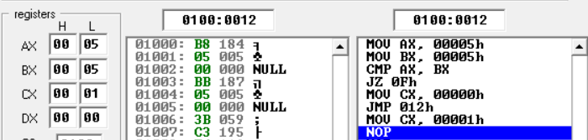
Combining Loop and Conditions:
MOV AX, 0 ; Start value
MOV CX, 10 ; Loop counter = 10

START:
ADD AX, 1 ; Increase AX each iteration
CMP AX, 5 ; Compare AX with 5
JE FOUND ; If AX = 5, jump to FOUND
LOOP START ; Otherwise, continue loop

FOUND:
; AX = 5, program jumps here

Output
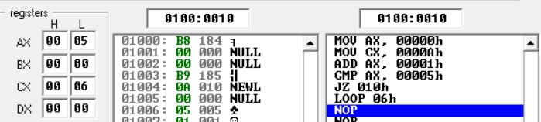
Explanation:
- AX increments each loop.
- CMP AX, 5 checks if AX has reached 5.
- When equal, JE breaks the loop early and jumps to FOUND.
- Otherwise, LOOP continues until CX = 0.

Task 1: Load AL = 2, then use JMP to skip over the instruction AL = 9. Verify AL still equals 2.
Task 2: Write a program that initializes AX = 0 and CX = 4, then uses LOOP to add 2 to AX each time.
Task 3: Write a program that compares AX and BX.
- If AX > BX, store 1 in DX.
- If AX < BX, store 2 in DX.
- If AX == BX, store 3 in DX.

Task 4: Write an assembly program that starts with AX = 10 and CX = 5.
- In each iteration, decrement AX by 1 (DEC AX).
- Use CMP to check if AX has reached 7.
- If equal, jump to a label STOP and end the loop early.

